Hybrid Network Setup
By
Joseph Tierney

Class: Computer Science 2

Tutor: Tony Bernes

Setting up a hybrid network involves setting up a wired machine and a wireless machine to the same router. For this task, I was setting up a wireless machine.

First, check all connections by typing cmd in the command prompt and then in the pop-up window type ipconfig /all to view all devices connected to the network, this includes the router.

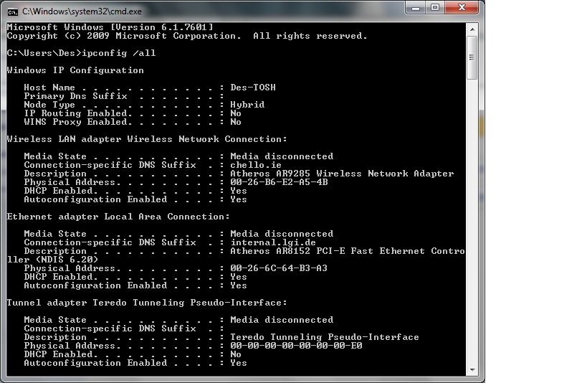

Before connecting to the router, turn off Firewall by clicking start and then selecting control panel. Select firewall and in the left panel select Turn Windows Firewall on or off.

Connect to the router by entering in the information for IP address, subnet mas and default gateway. Open Network and Sharing Centre, right click on Wireless connection and click properties. Click on IP ver 4 and then properties. Set the manual address to 192.168.1.13, Subnet mask is set to 255.255.255.0 by default, and the Default Gateway set to 192.168.1.254

After connecting to the router, ping a wired machine and a wireless machine by typing cmd in the command prompt and then in the pop up window type ping 192.168.1.17 (this machine is wired) or type ping 192.168.1.11 (this machine is wireless).

